

Virtual Cloud Computing

Assignment - 2 Report

Completed By

### “Geetika Vijay”

“G23AI2098”

Git URL: “https://github.com/GeetikaVijay/VCC_Assignment-2_GCP.git”

**Assignment Details:**

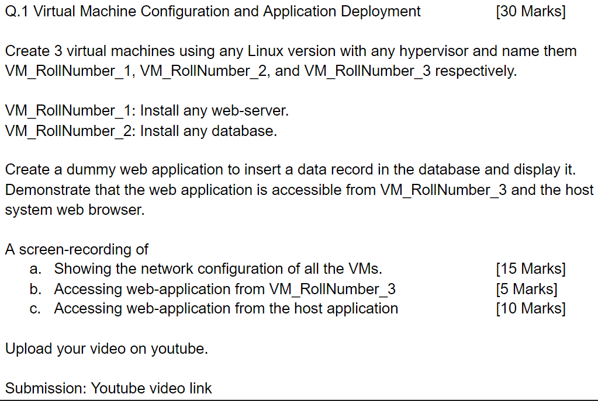

* **Part a) Creating 3 VMs and showing their network configurations and connectivity:**

VPC Setup

* Logged in Google Cloud account and created three virtual machines:

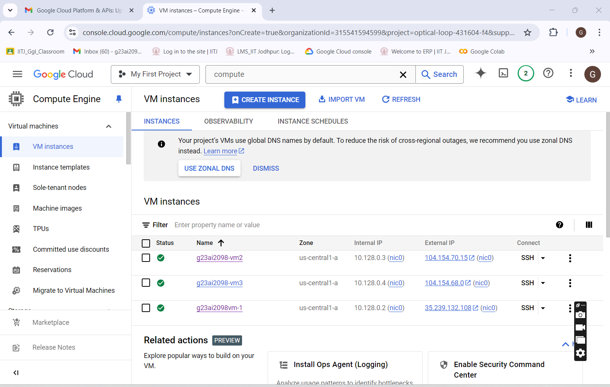

* Network configurations & Other details for 3 machines created on Google cloud :
* [g23ai2098vm-1](https://console.cloud.google.com/compute/instancesDetail/zones/us-central1-a/instances/g23ai2098vm-1?organizationId=315541594599&project=optical-loop-431604-f4&supportedpurview=project), [g23ai2098-vm2](https://console.cloud.google.com/compute/instancesDetail/zones/us-central1-a/instances/g23ai2098-vm2?organizationId=315541594599&project=optical-loop-431604-f4&supportedpurview=project), [g23ai2098-vm3](https://console.cloud.google.com/compute/instancesDetail/zones/us-central1-a/instances/g23ai2098-vm3?organizationId=315541594599&project=optical-loop-431604-f4&supportedpurview=project)
* Network Configuration of VM-1 i.e. g23ai2098vm-1 –

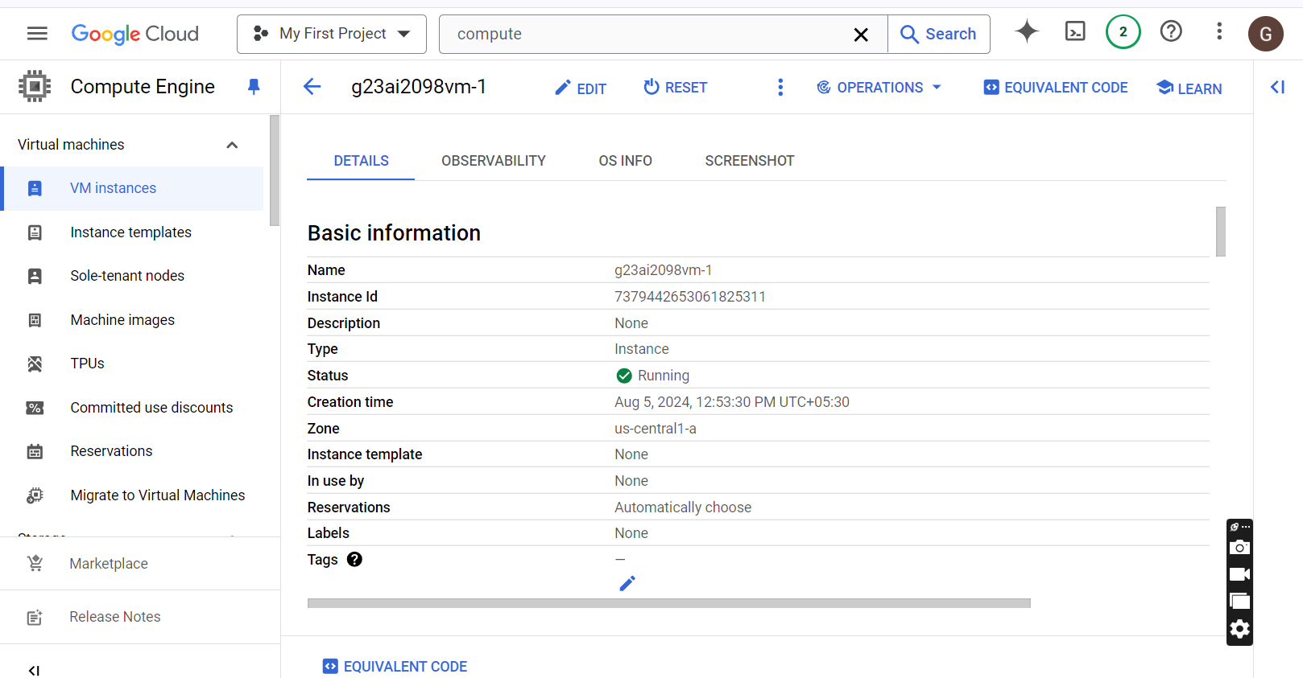

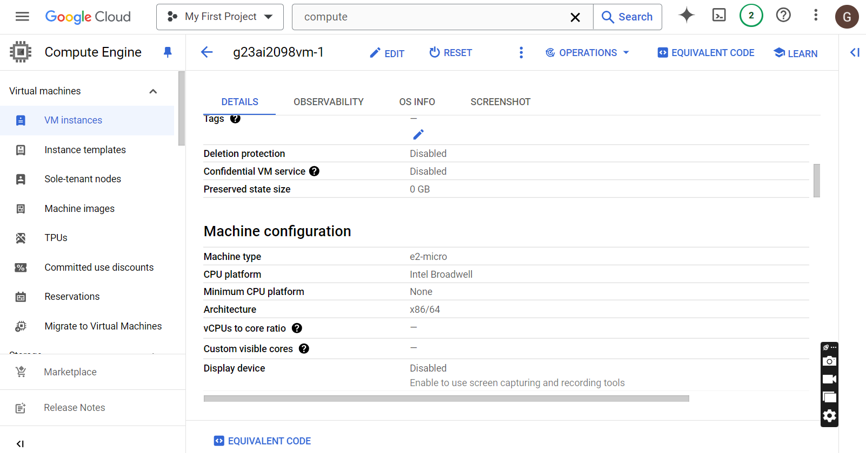

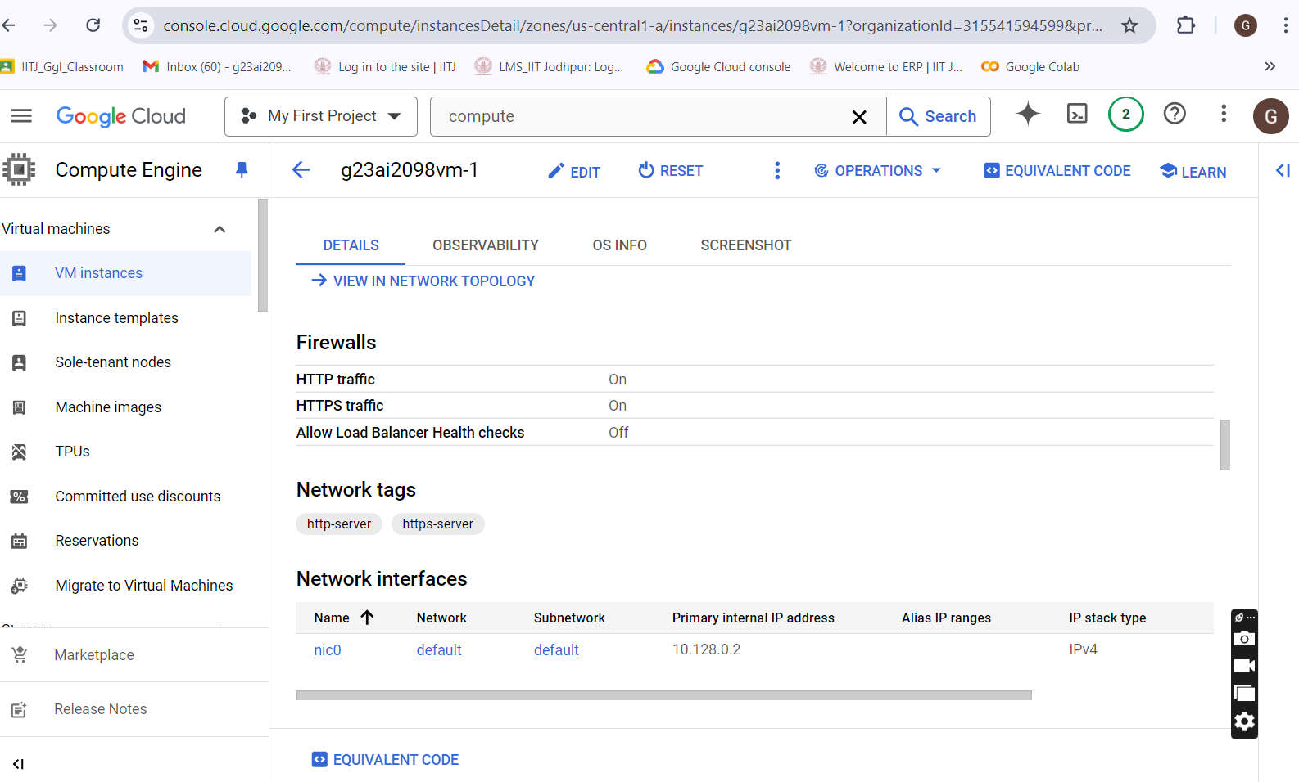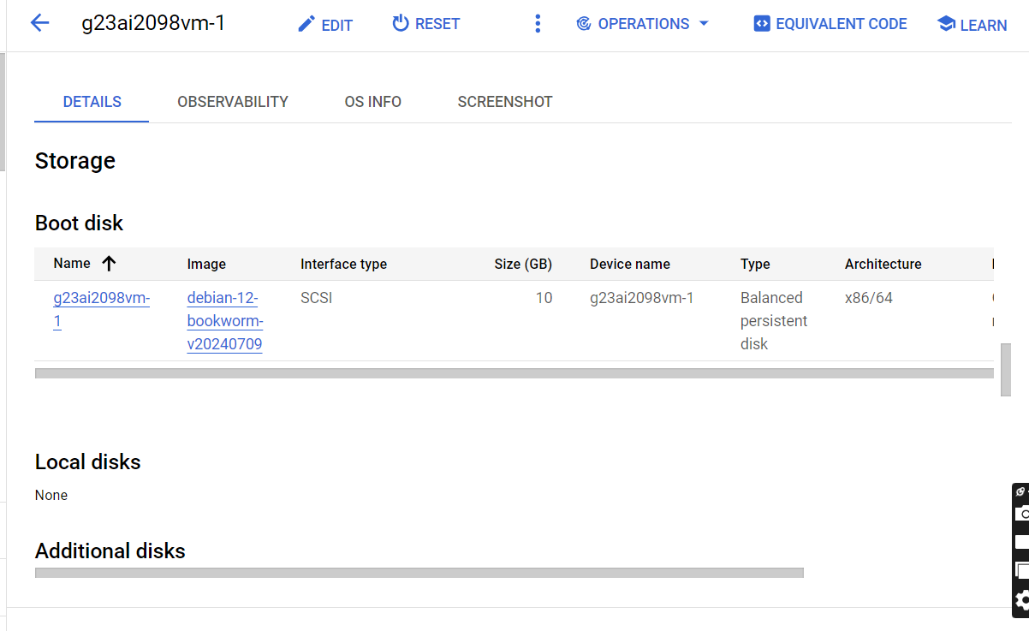

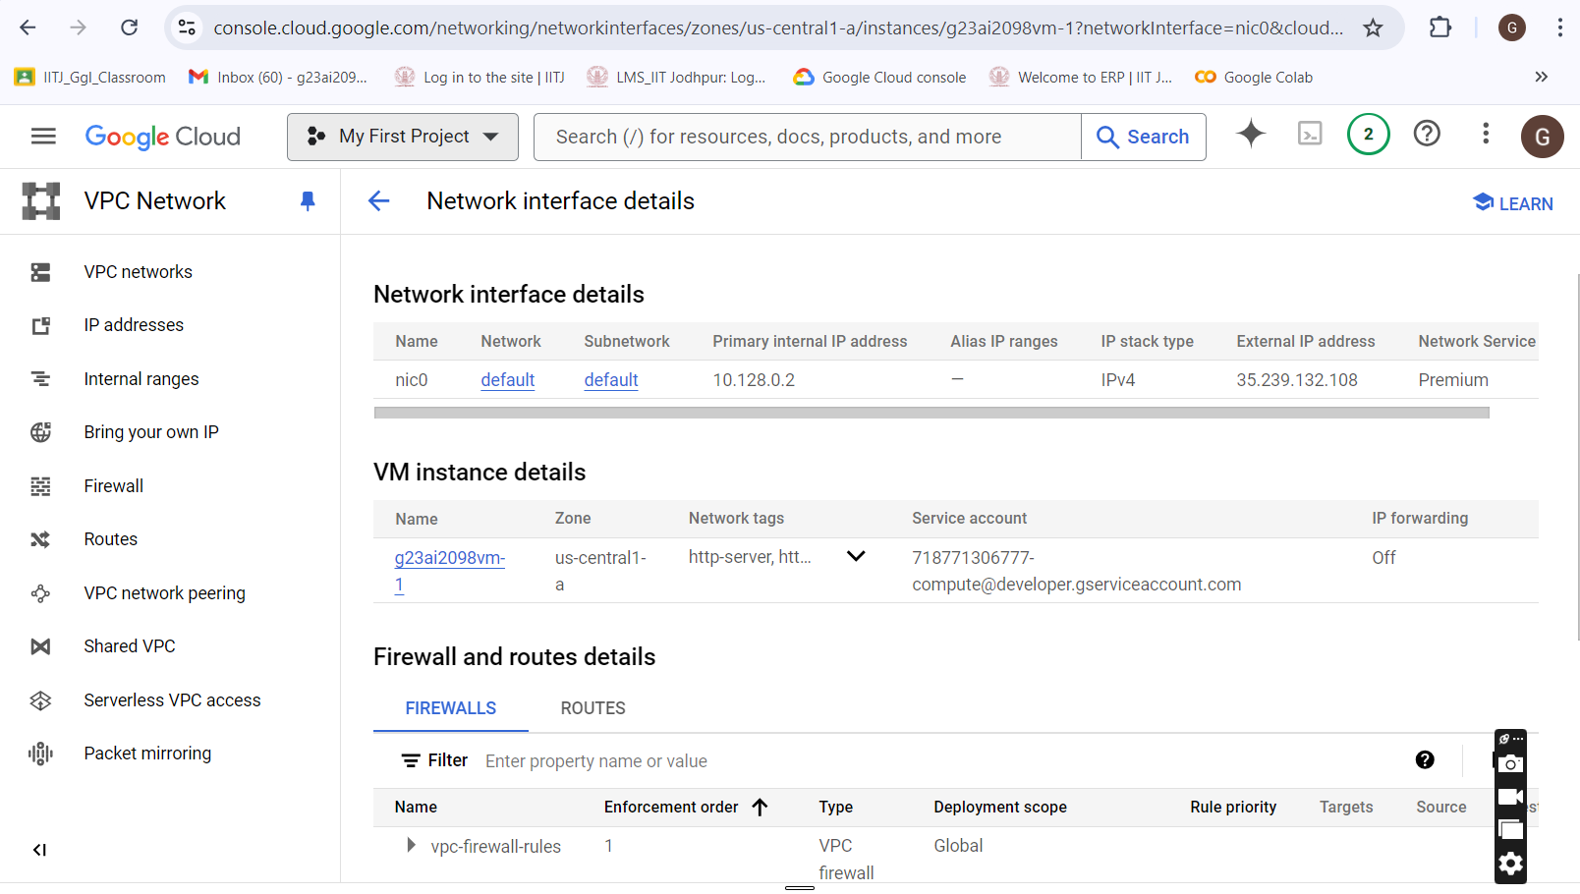

* Network Configuration of VM-2:
* [g23ai2098-vm2](https://console.cloud.google.com/compute/instancesDetail/zones/us-central1-a/instances/g23ai2098-vm2?organizationId=315541594599&project=optical-loop-431604-f4&supportedpurview=project)

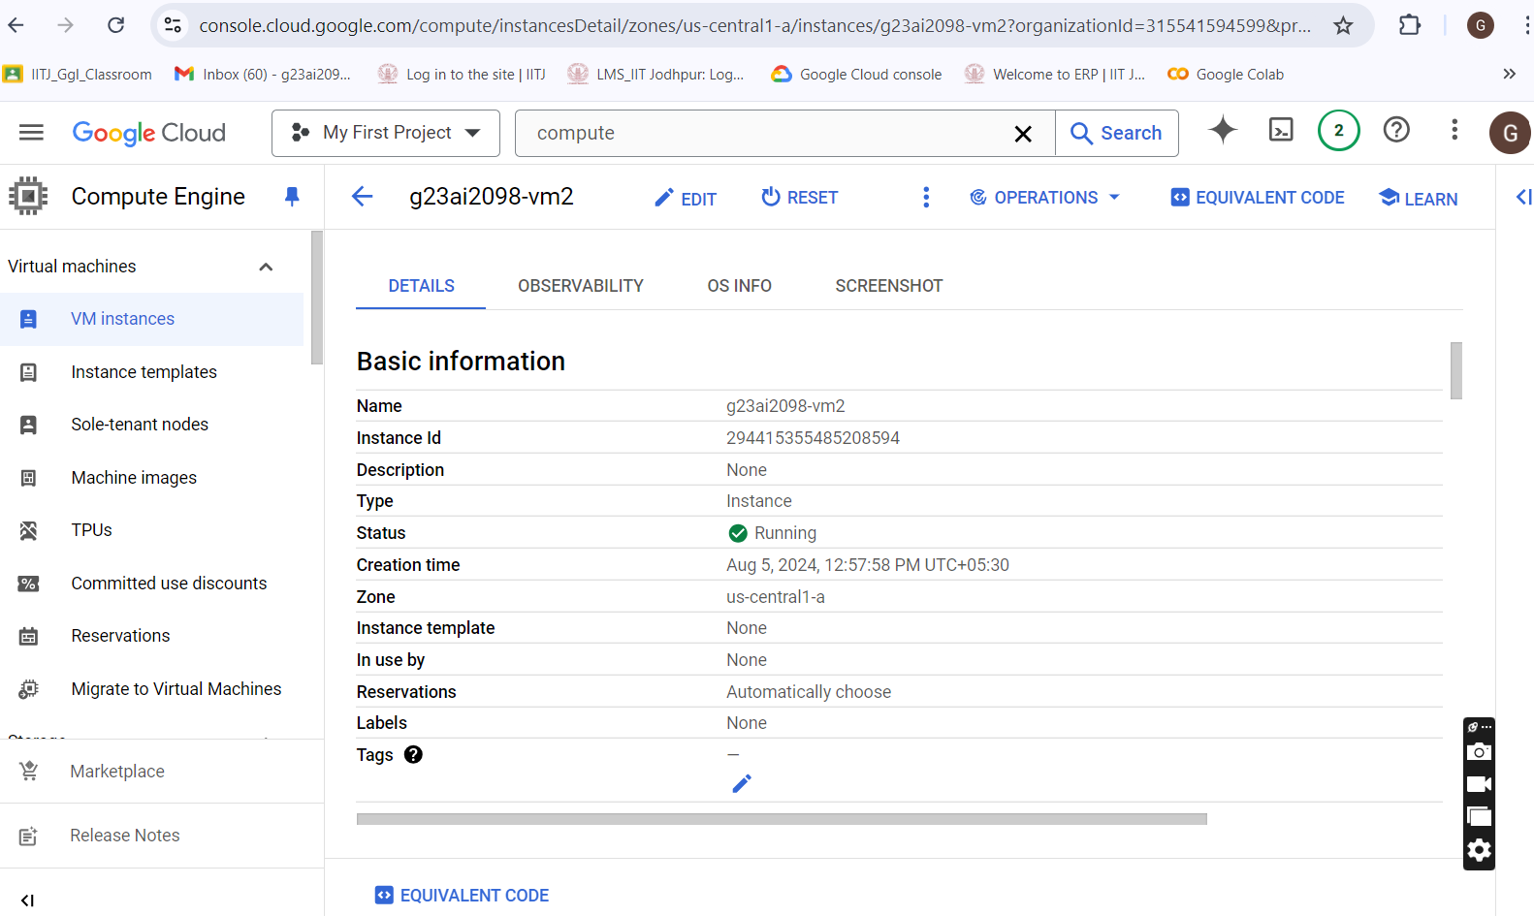

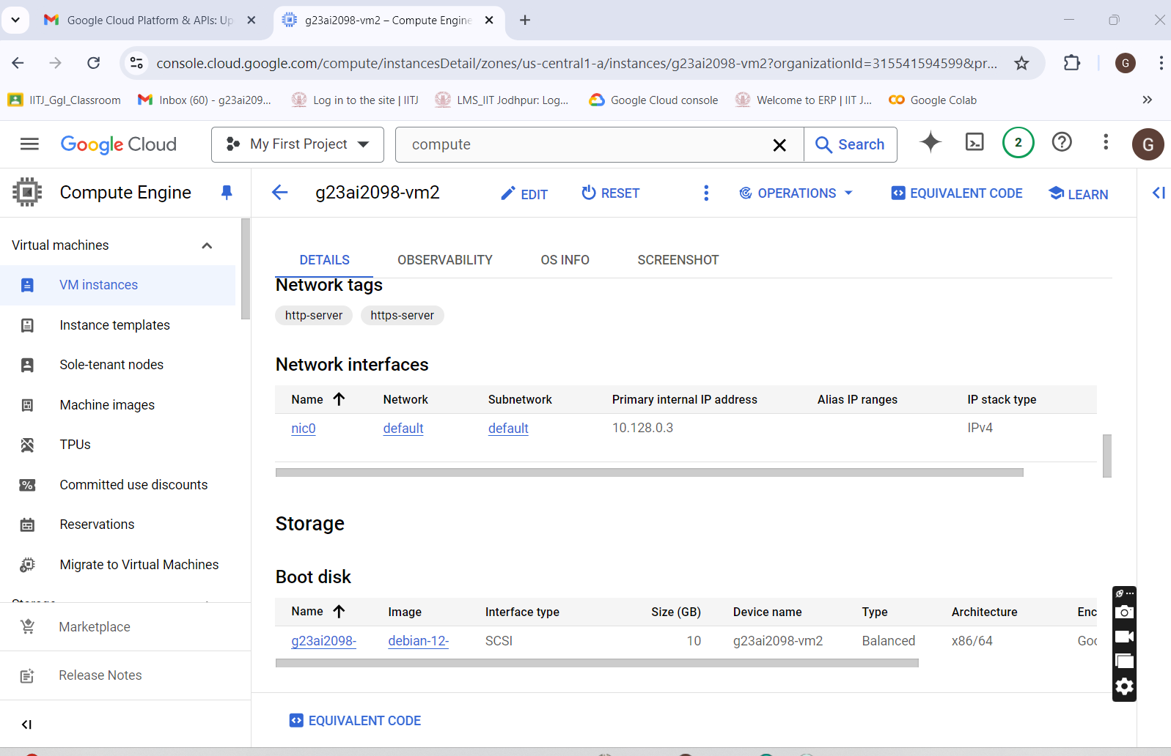

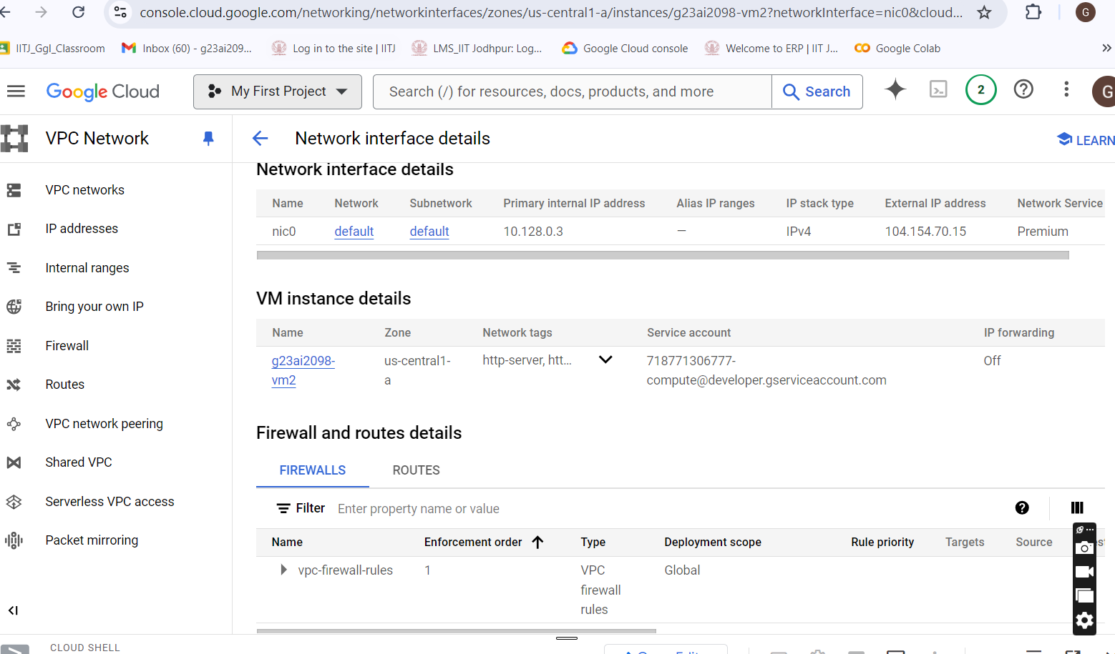

* Network Configuration of VM-3:

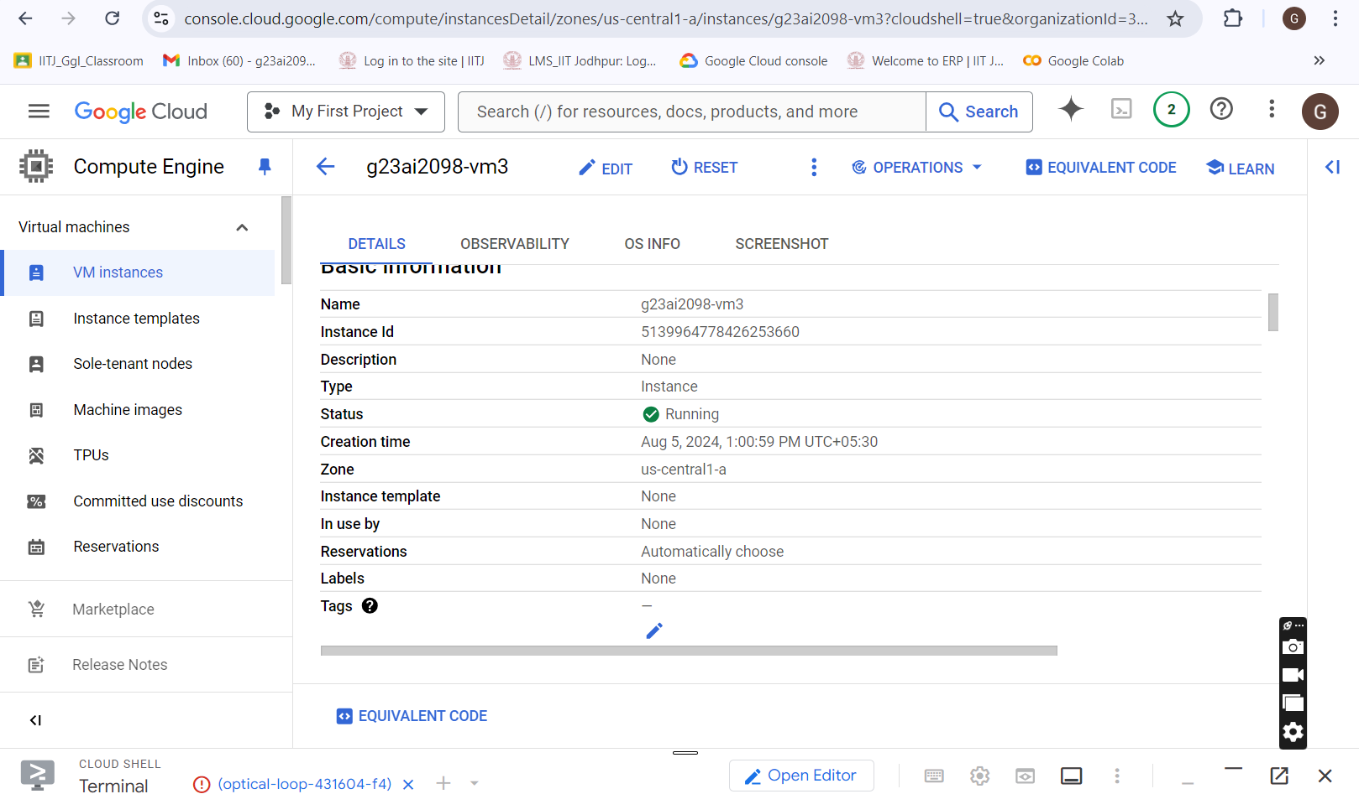

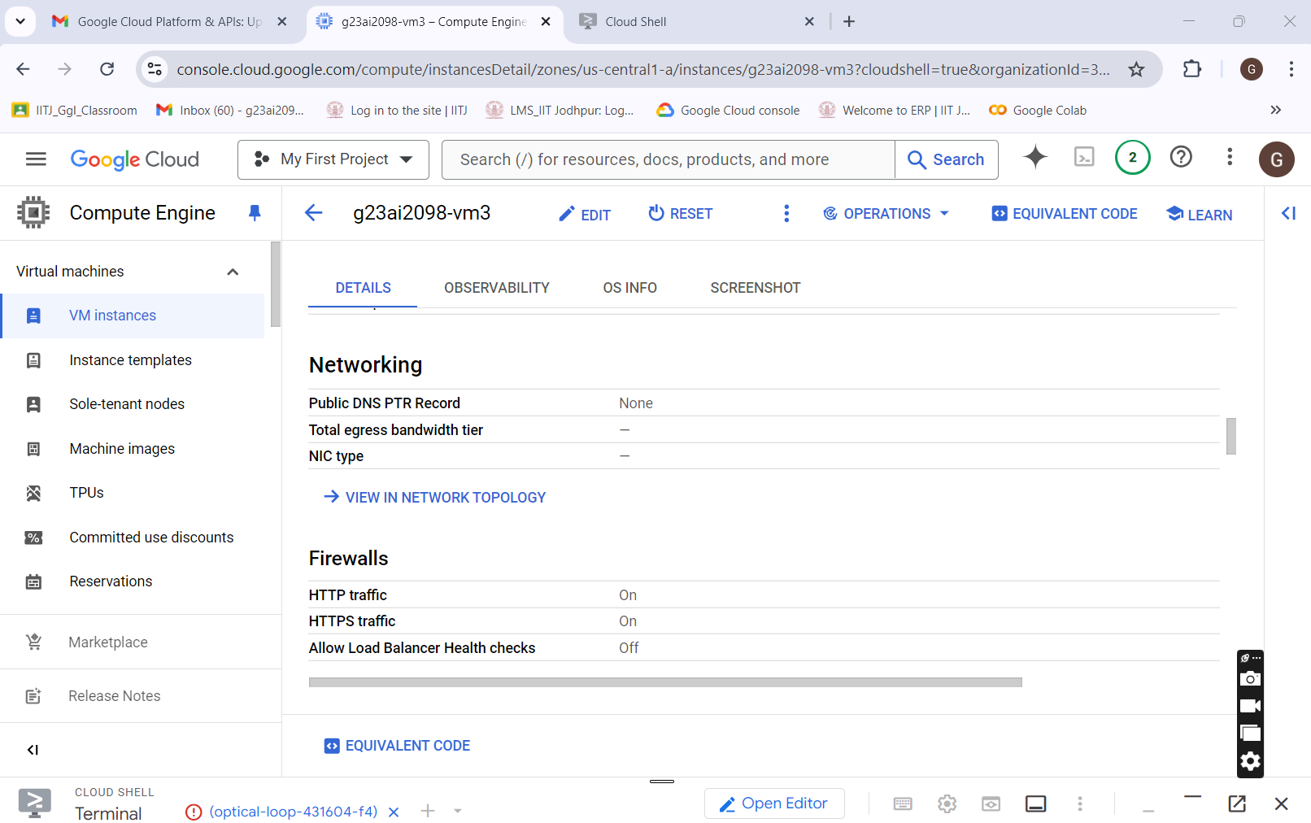

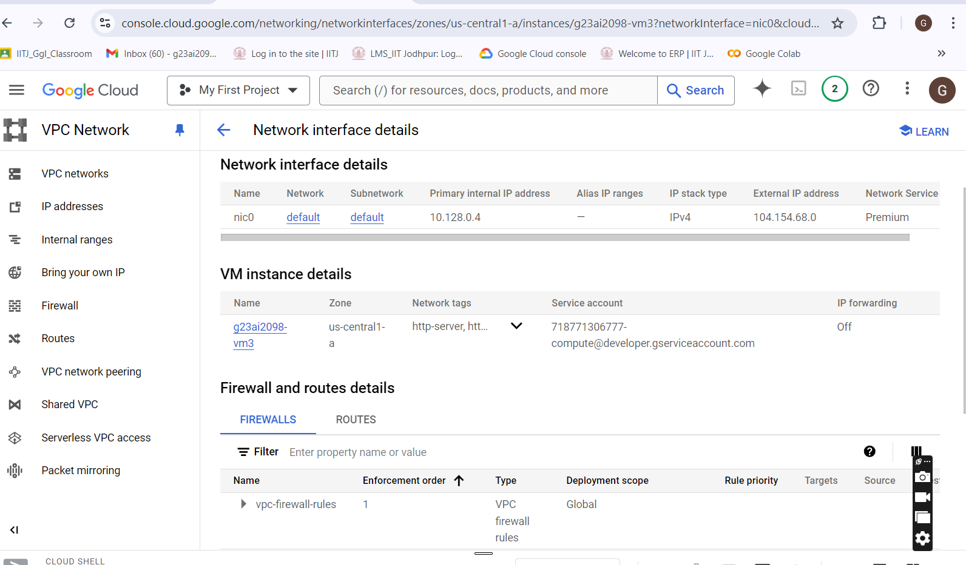

* **Connectivity of all 3 virtual machines with each other and with Host Machine:**
* [g23ai2098vm-1](https://console.cloud.google.com/compute/instancesDetail/zones/us-central1-a/instances/g23ai2098vm-1?organizationId=315541594599&project=optical-loop-431604-f4&supportedpurview=project) : 35.239.132.108
* [g23ai2098-vm2](https://console.cloud.google.com/compute/instancesDetail/zones/us-central1-a/instances/g23ai2098-vm2?organizationId=315541594599&project=optical-loop-431604-f4&supportedpurview=project) : 104.154.70.15
* [g23ai2098-vm3](https://console.cloud.google.com/compute/instancesDetail/zones/us-central1-a/instances/g23ai2098-vm3?organizationId=315541594599&project=optical-loop-431604-f4&supportedpurview=project) : [104.154.68.0](https://104.154.68.0/)
* Host Machine : 192.168.0.105

[g23ai2098vm-1](https://console.cloud.google.com/compute/instancesDetail/zones/us-central1-a/instances/g23ai2098vm-1?organizationId=315541594599&project=optical-loop-431604-f4&supportedpurview=project) : 35.239.132.108

This virtual machine (VM) is configured with default networking and utilizes the *'e2-micro’* machine type, running Debian GNU/Linux 12 as the operating system. It hosts a Python web server capable of connecting to a MySQL database, allowing users to view and insert data through a provided graphical user interface (GUI).

[g23ai2098-vm2](https://console.cloud.google.com/compute/instancesDetail/zones/us-central1-a/instances/g23ai2098-vm2?organizationId=315541594599&project=optical-loop-431604-f4&supportedpurview=project) : 104.154.70.15

This Virtual Machine (VM) is configured with default networking and utilizes the 'e2- *micro’* machine type, running Debian GNU/Linux 12 as the operating system. It is designated to host the MySQL server.

[g23ai2098-vm3](https://console.cloud.google.com/compute/instancesDetail/zones/us-central1-a/instances/g23ai2098-vm3?organizationId=315541594599&project=optical-loop-431604-f4&supportedpurview=project) : [104.154.68.0](https://104.154.68.0/)

This virtual machine (VM) is configured with default networking and utilizes the *'e2-micro’* machine type, running Debian GNU/Linux 12 as the operating system. It is used to demonstrating VM to VM accessibility.

* **Firewall Rules Creation**

There are two firewall rules created to enable access to Mysql server and Web server hosted in the Virtual Machine

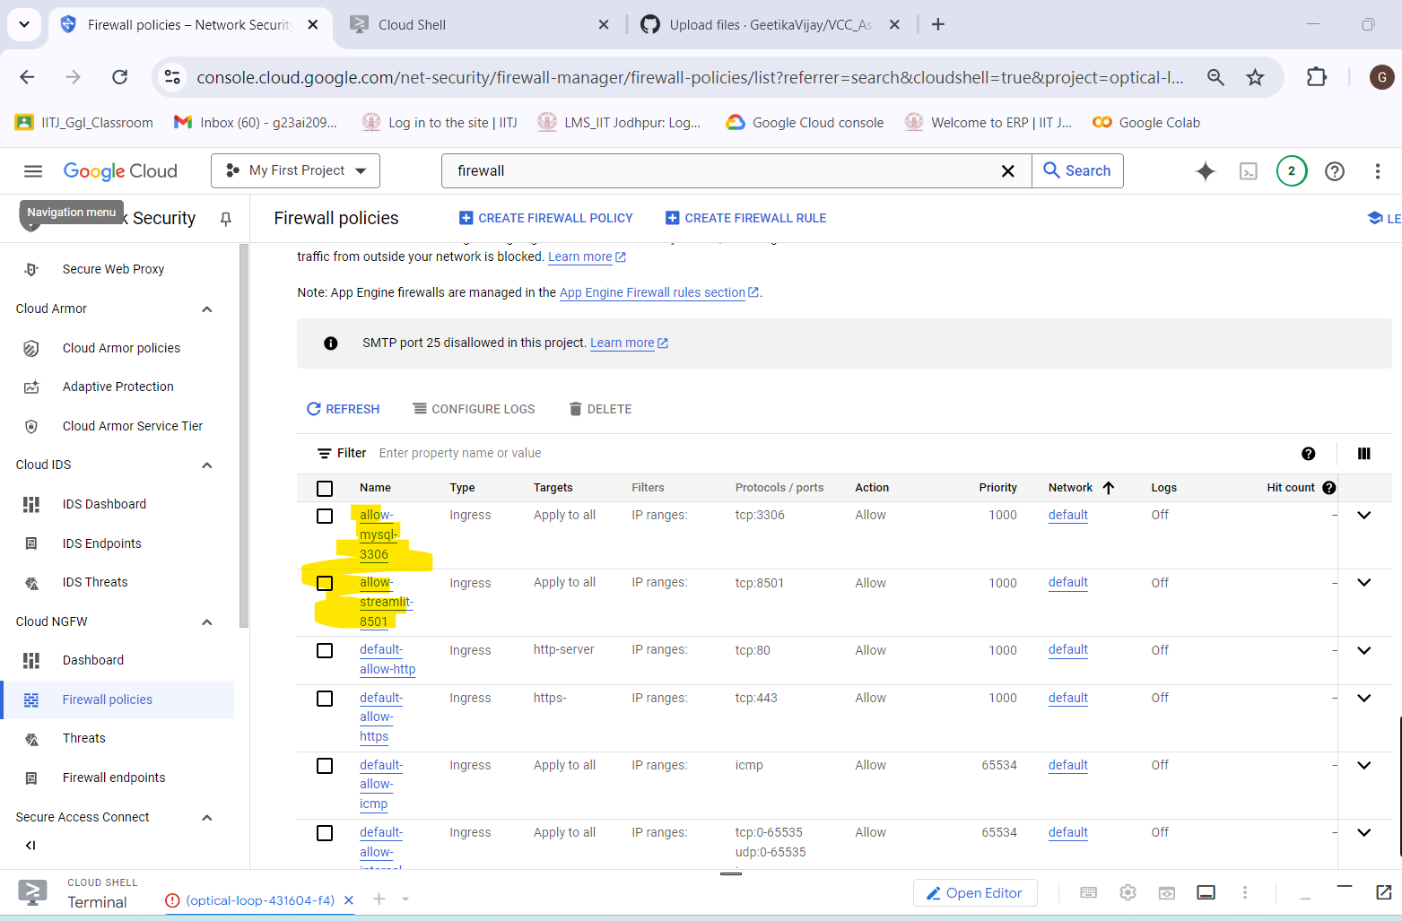

* **allow-mysql-3306**

This firewall is created to enable the tcp:3306 port which enables the python web server to connect to MySql server.

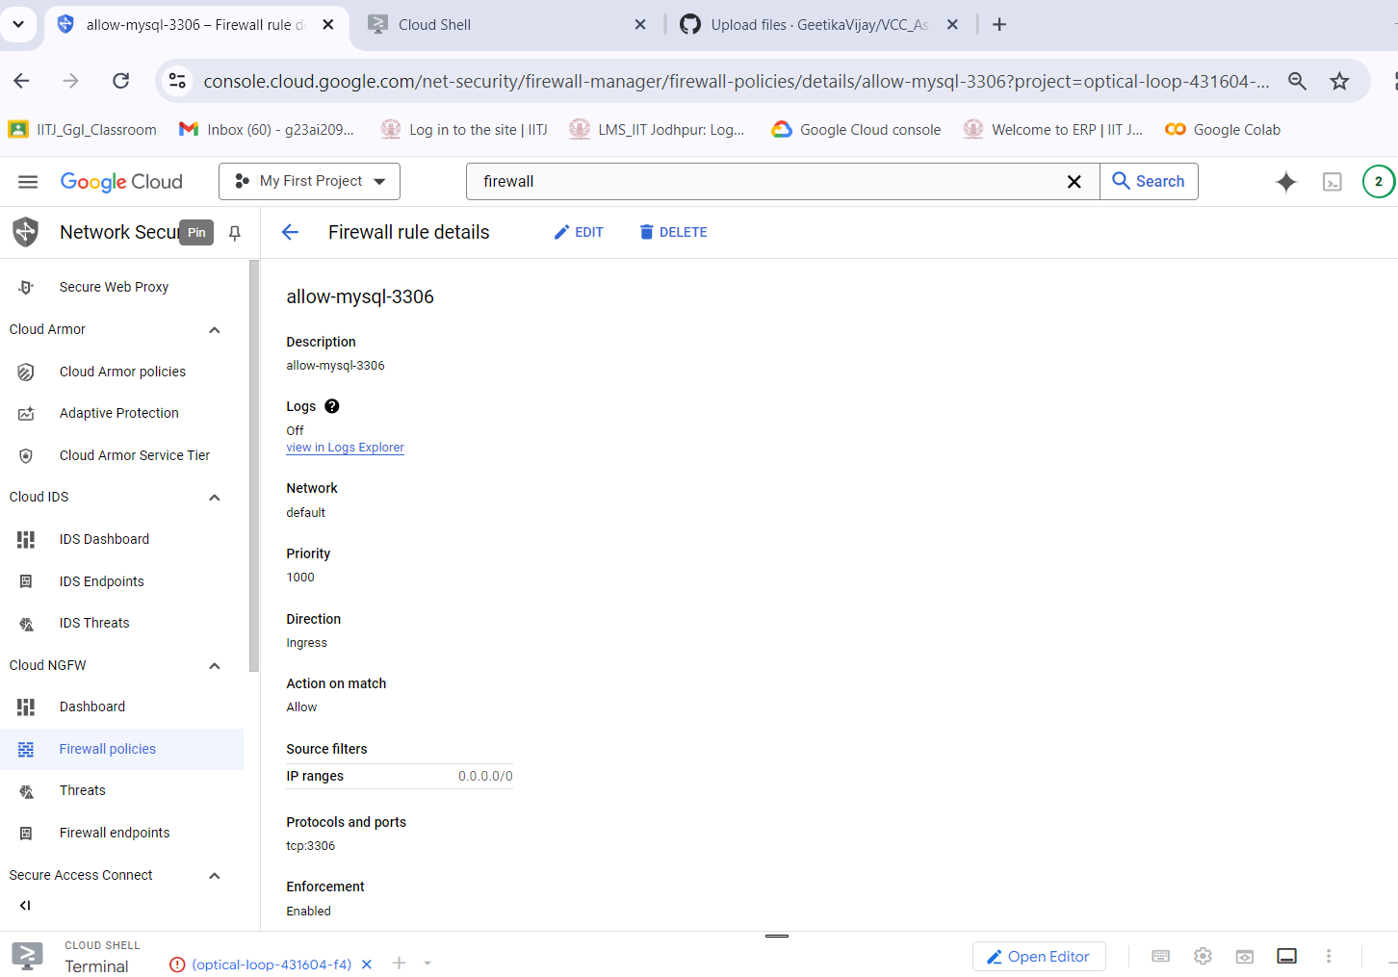

* **allow-streamlit-8501**

This firewall is created to enable the tcp:8501 port which enables the web server to be accessible from external ip as well from other VM.

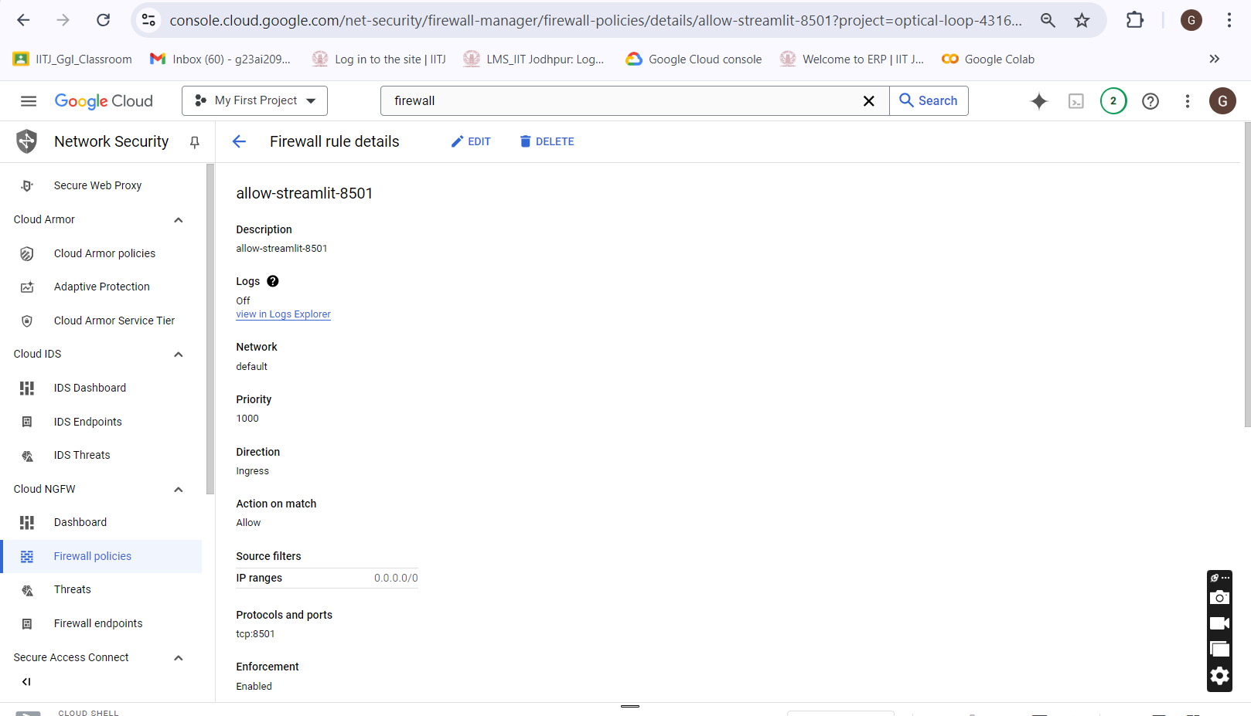

* [**g23ai2098vm-1**](https://console.cloud.google.com/compute/instancesDetail/zones/us-central1-a/instances/g23ai2098vm-1?organizationId=315541594599&project=optical-loop-431604-f4&supportedpurview=project) **successfully pinged all 3 Virtual Machines:**

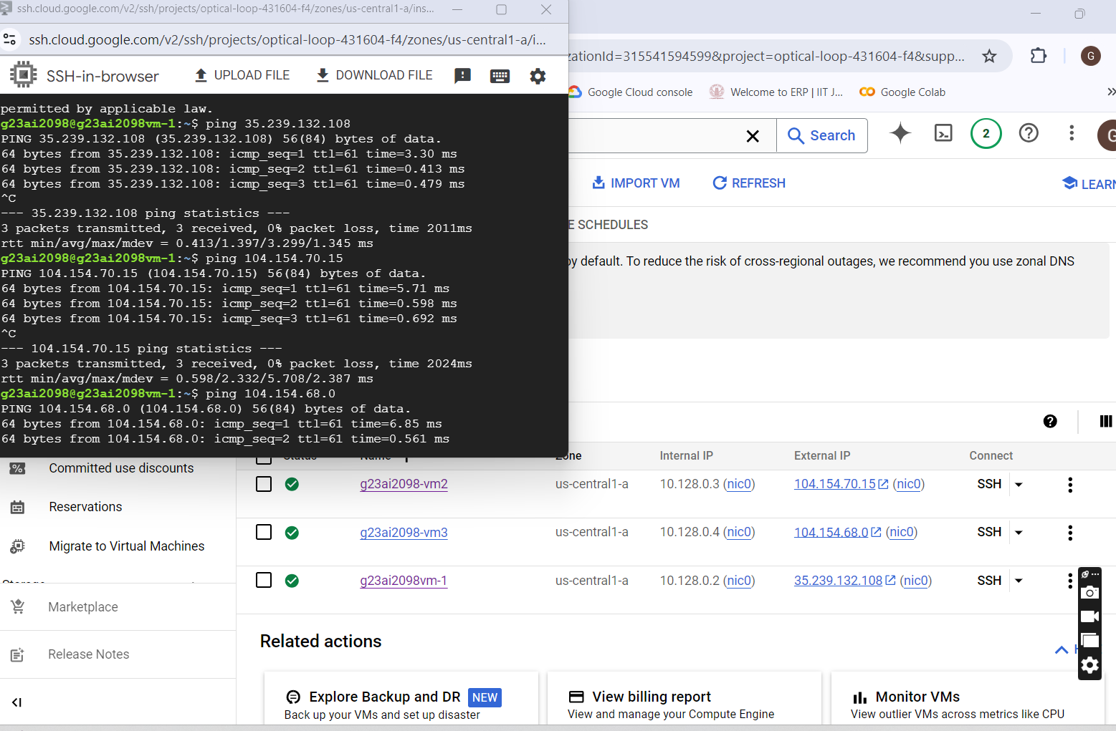

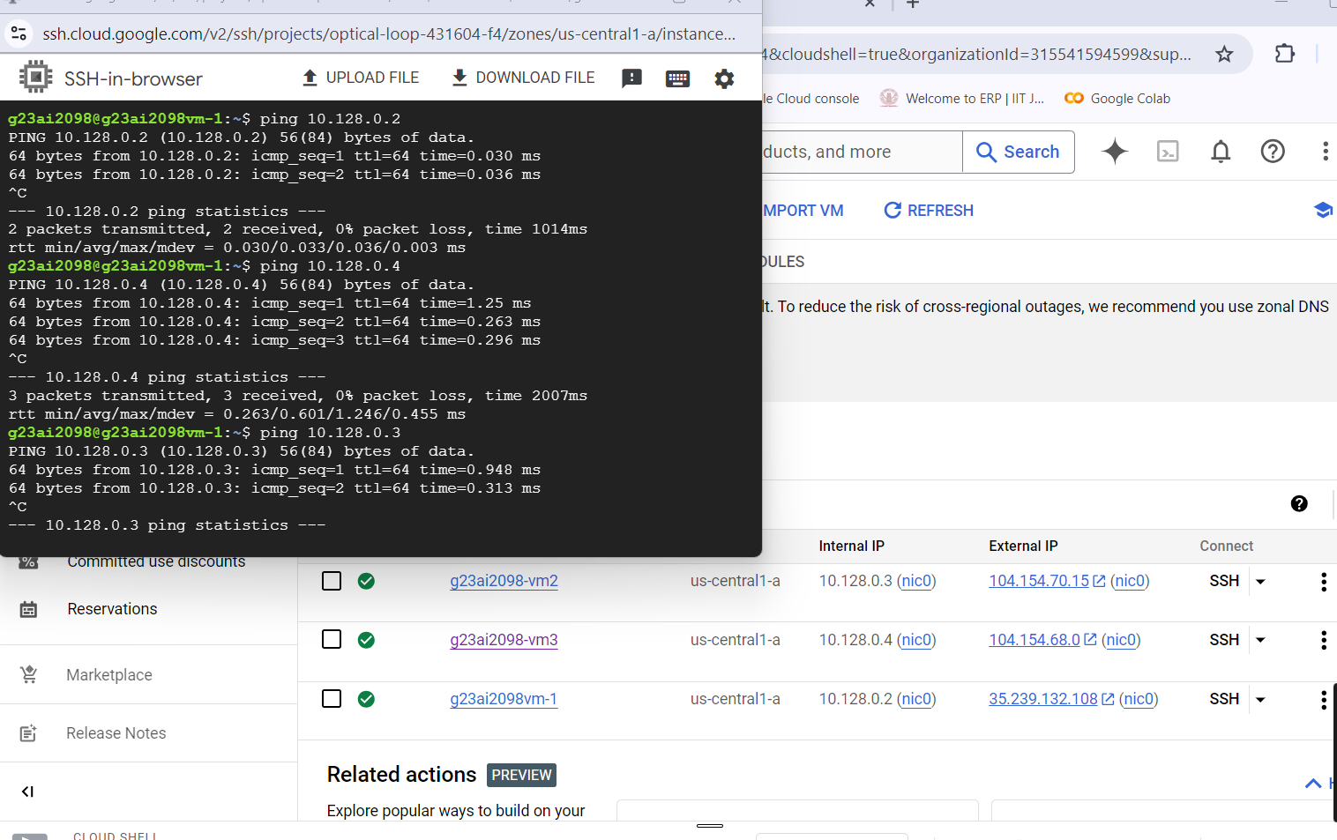

* [**g23ai2098-vm2**](https://console.cloud.google.com/compute/instancesDetail/zones/us-central1-a/instances/g23ai2098-vm2?organizationId=315541594599&project=optical-loop-431604-f4&supportedpurview=project) **successfully pinged all 3 VMs:**

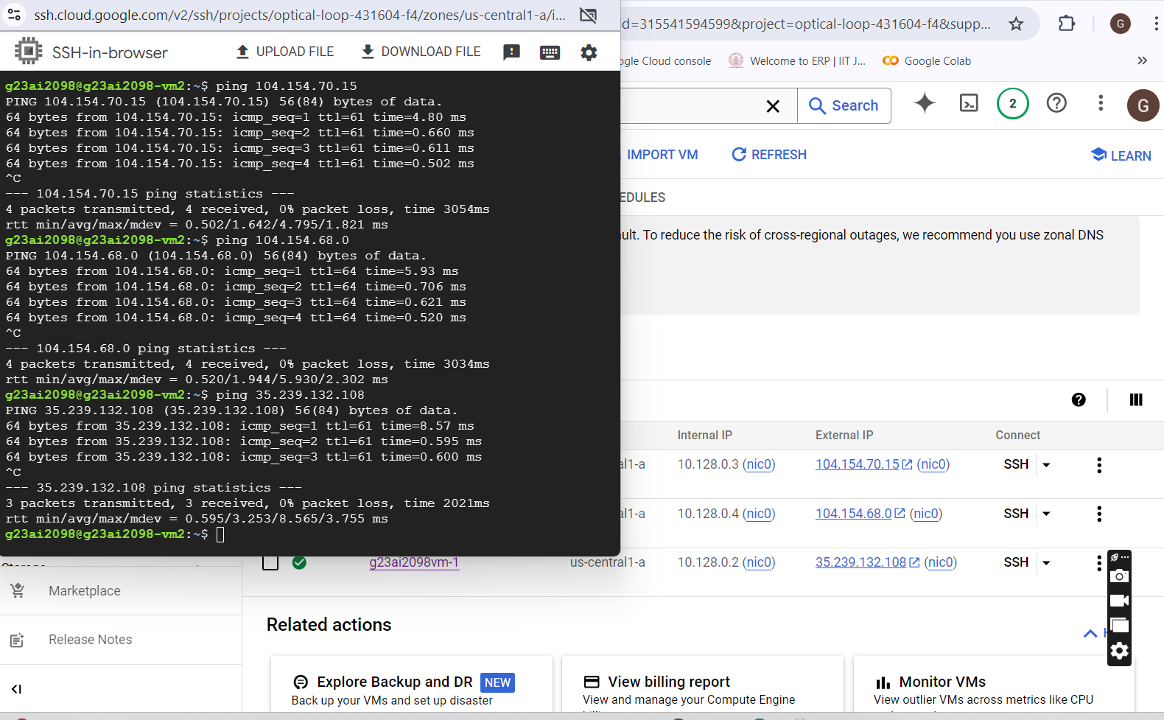

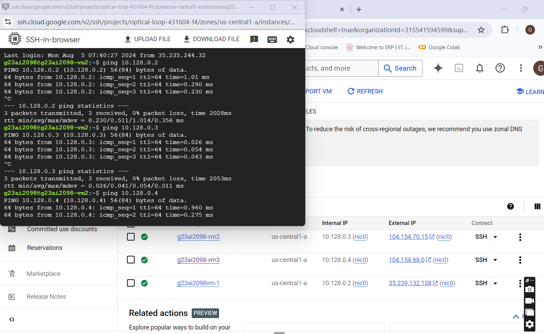

* [**g23ai2098-vm3**](https://console.cloud.google.com/compute/instancesDetail/zones/us-central1-a/instances/g23ai2098-vm3?organizationId=315541594599&project=optical-loop-431604-f4&supportedpurview=project) **successfully pinged all 3 VMs:**

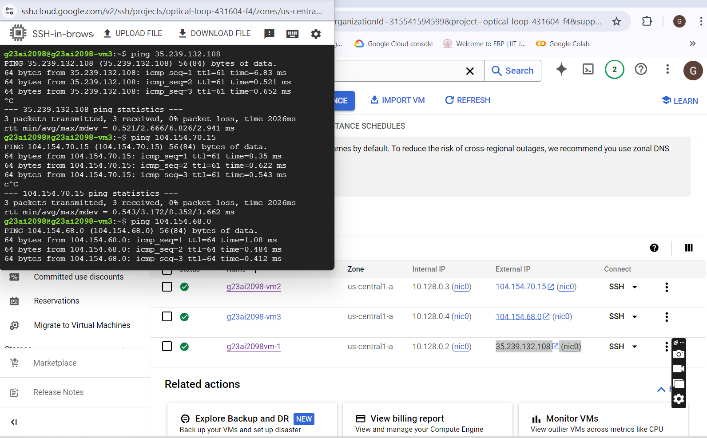

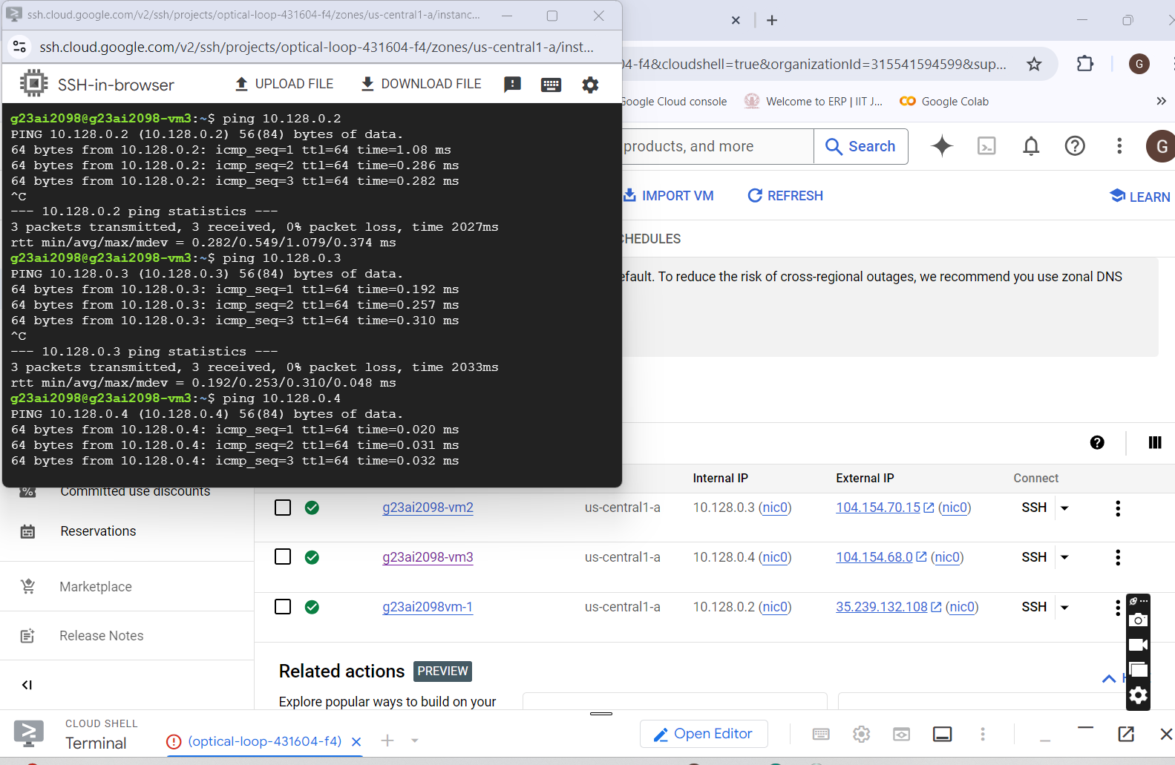

* **Host machine successfully able to ping all 3 VMS:**

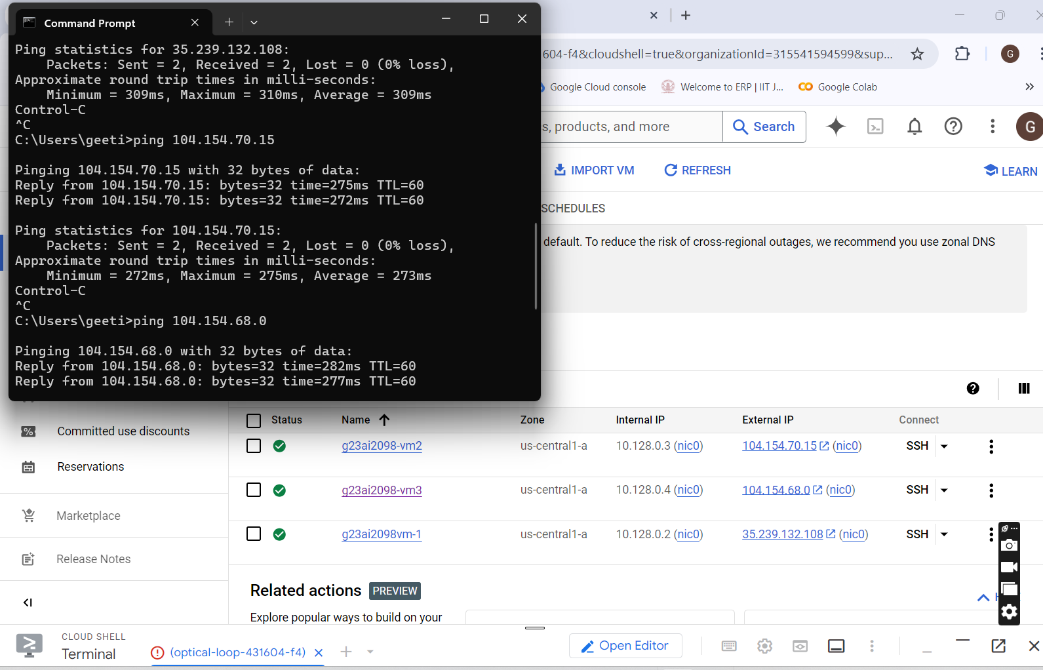

* **Part2)**

1. **Web Server apache2 installed on VM1 -** [**g23ai2098vm-1**](https://console.cloud.google.com/compute/instancesDetail/zones/us-central1-a/instances/g23ai2098vm-1?organizationId=315541594599&project=optical-loop-431604-f4&supportedpurview=project) **:** [**35.239.132.108**](https://35.239.132.108/)
2. **Installation of any database on VM-2 --** [**g23ai2098-vm2**](https://console.cloud.google.com/compute/instancesDetail/zones/us-central1-a/instances/g23ai2098-vm2?project=optical-loop-431604-f4&supportedpurview=project) **:** [**104.154.70.15**](https://35.239.132.108/)

* **Successful Installation of Web Server:**

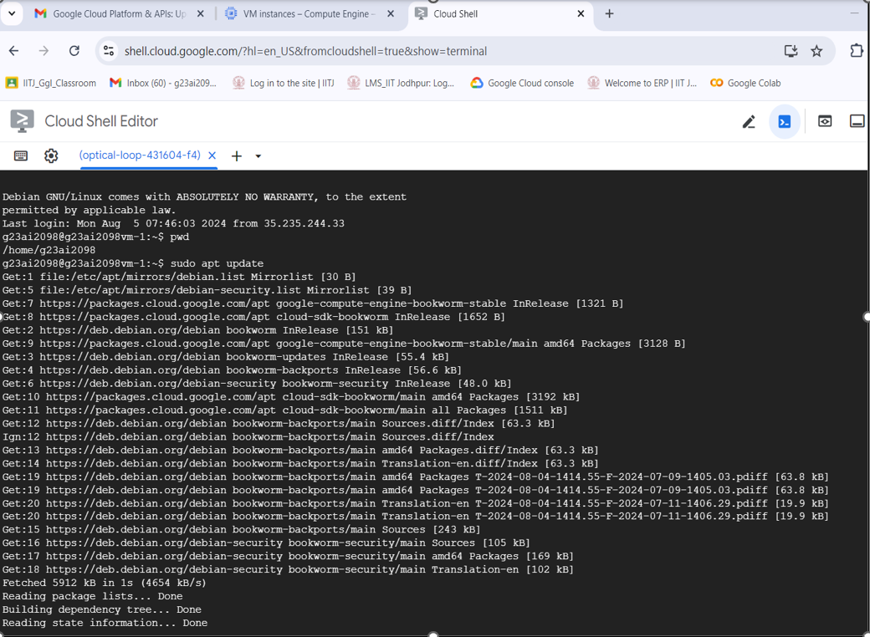

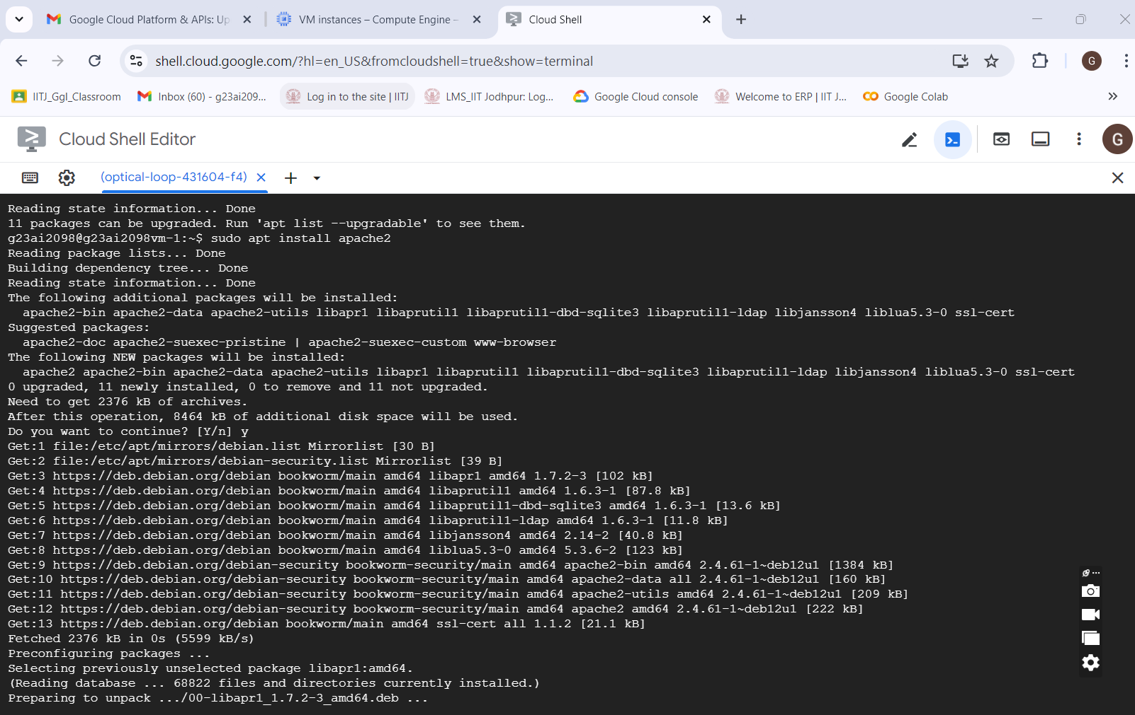

* **Successful Installation of Database Server:** Install any database on VM-2 -- [g23ai2098-vm2](https://console.cloud.google.com/compute/instancesDetail/zones/us-central1-a/instances/g23ai2098-vm2?project=optical-loop-431604-f4&supportedpurview=project)

sudo apt install mysql-server

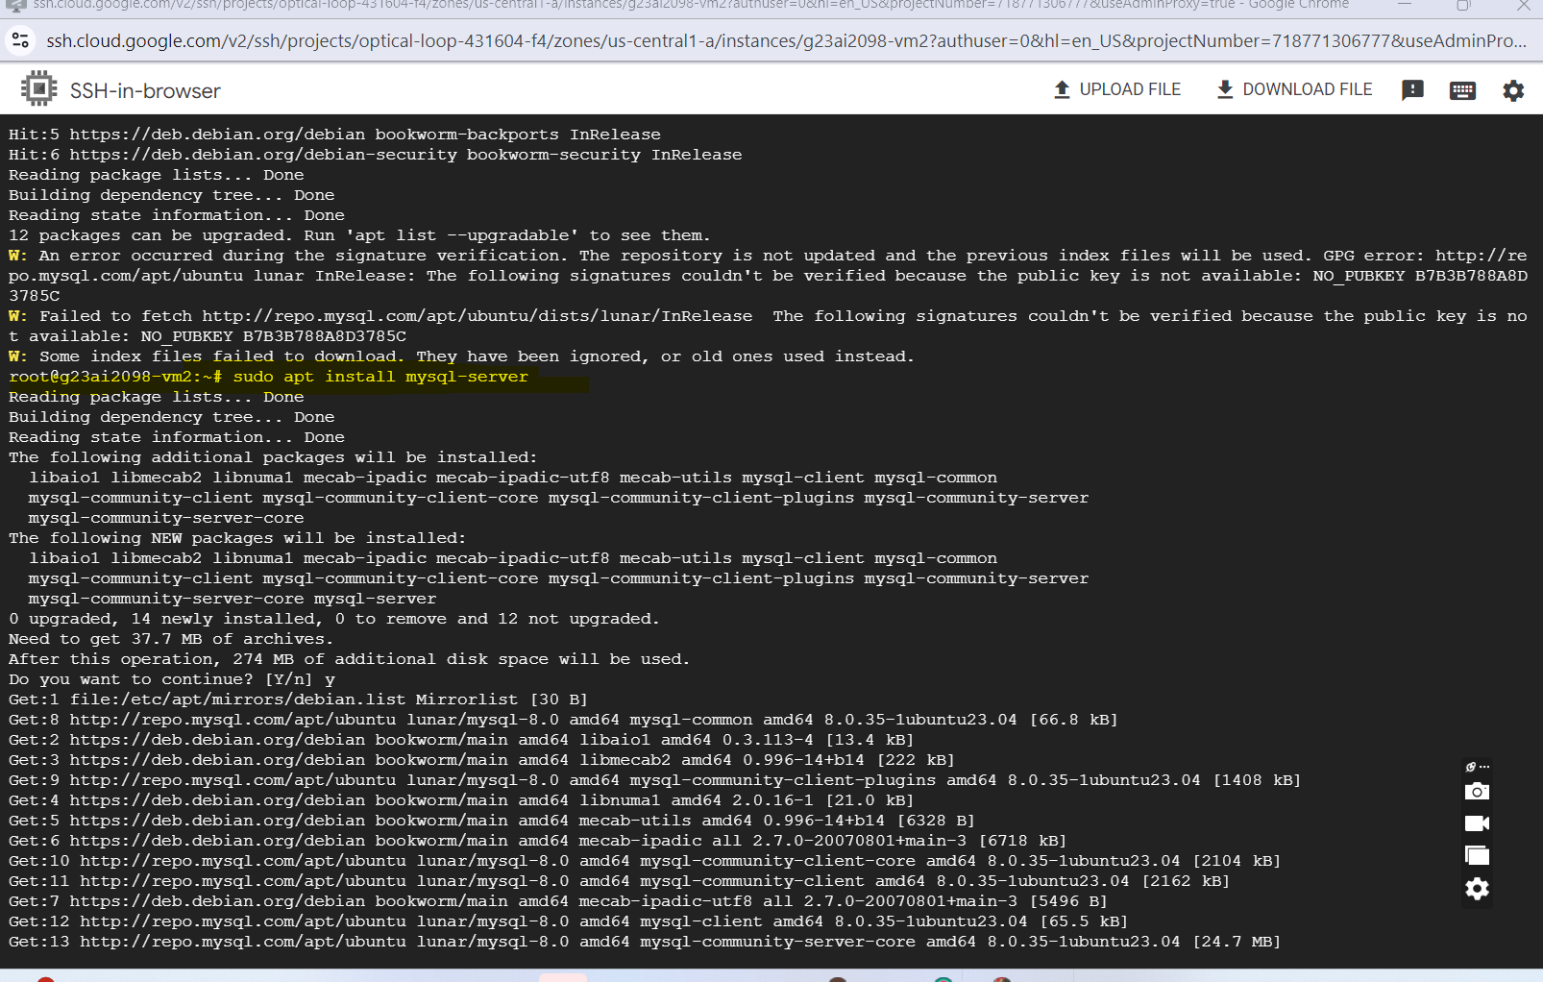

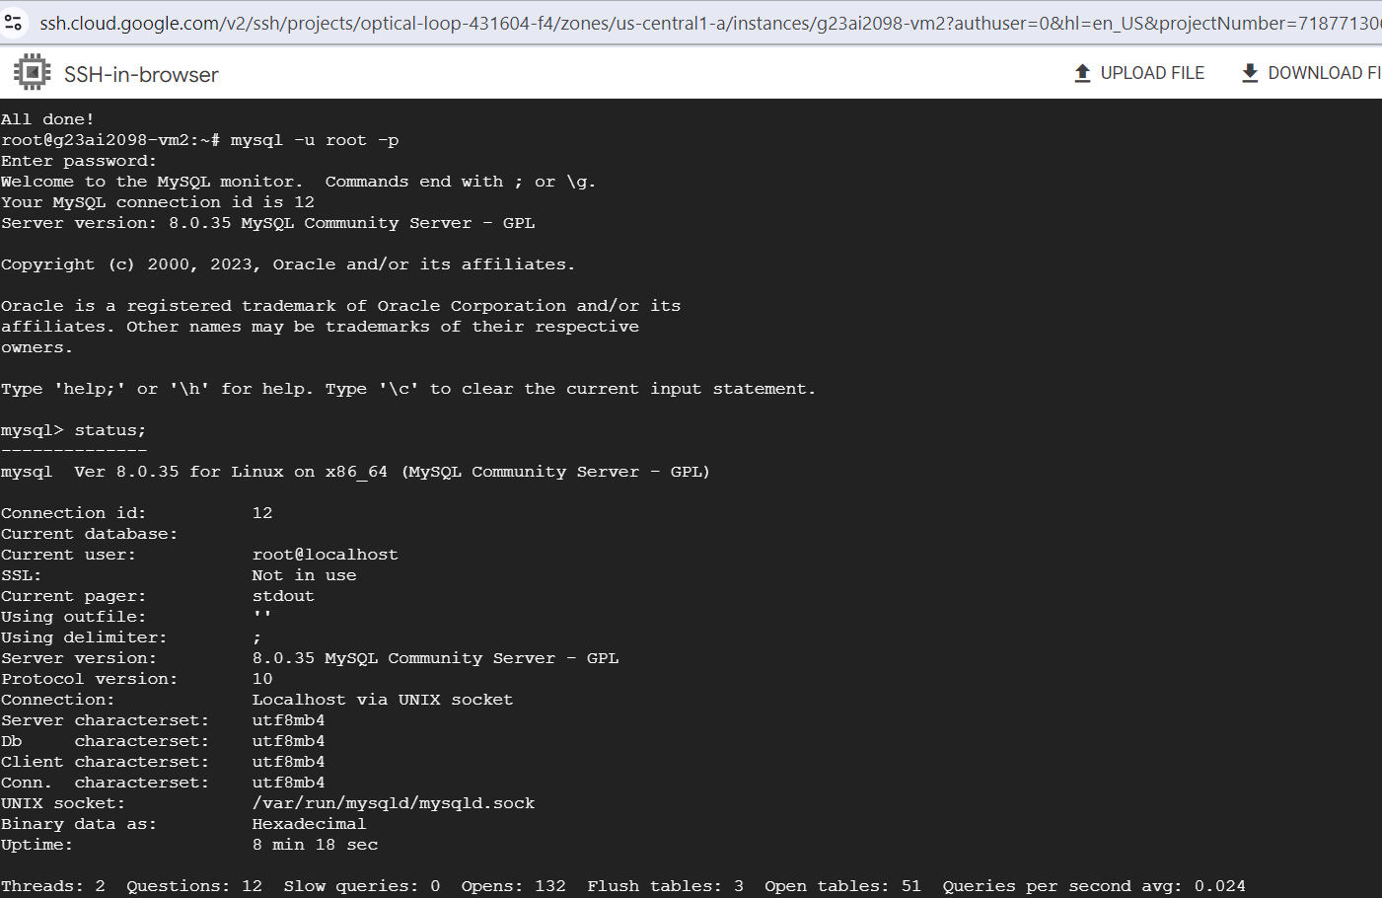

* **Database “EMPLOYEES” and table “employees” created in installed database in VM2**

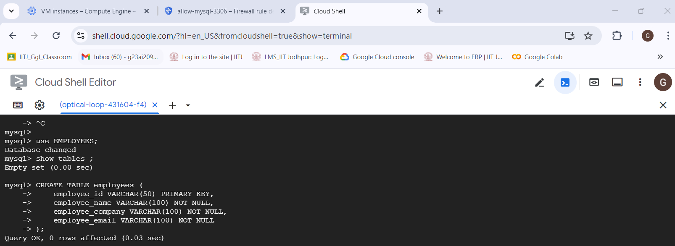

* **Data Successfully created in virtual machine 2 in employee table**

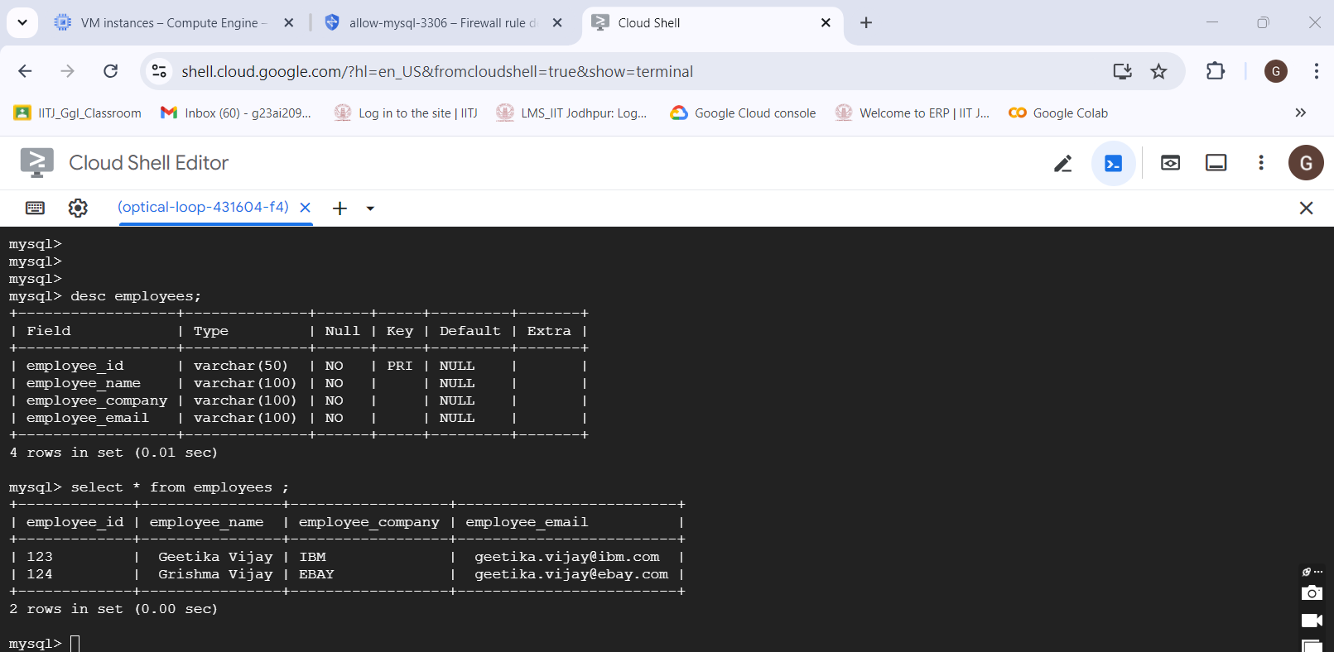

* **Part 3)**
* **VM3 is successfully able to access VM1 already shown above through ping**
* **All 3 Virtual Machines created on Google Cloud are running Successfully**

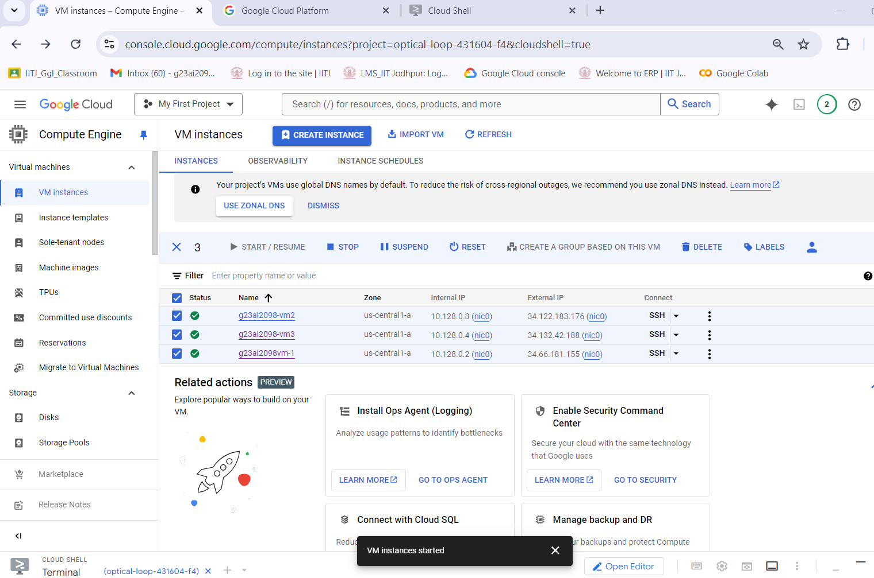

**Now access webapp hosted on VM-1 from host machine** VM1- [g23ai2098vm-1](https://console.cloud.google.com/compute/instancesDetail/zones/us-central1-a/instances/g23ai2098vm-1?cloudshell=true&project=optical-loop-431604-f4)- IP : 34.66.181.155

**Host machine is successfully able to access web server page hosted on VM 1 :**

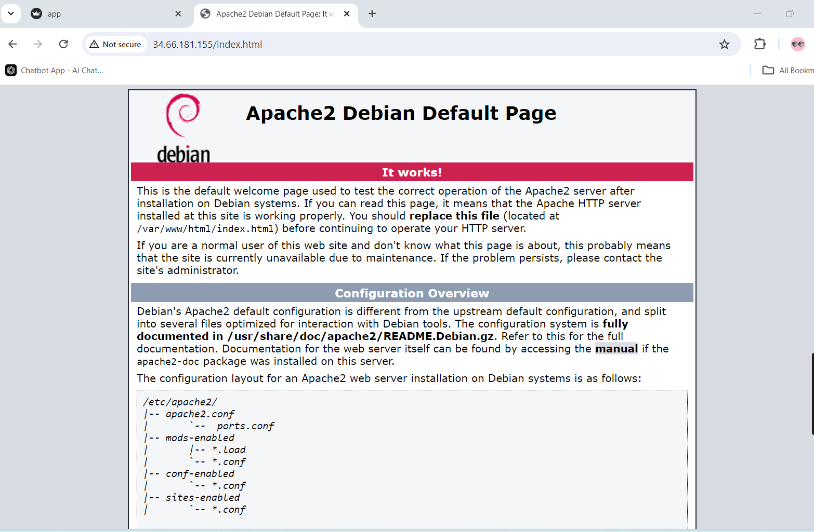

* Host Machine IP Address:

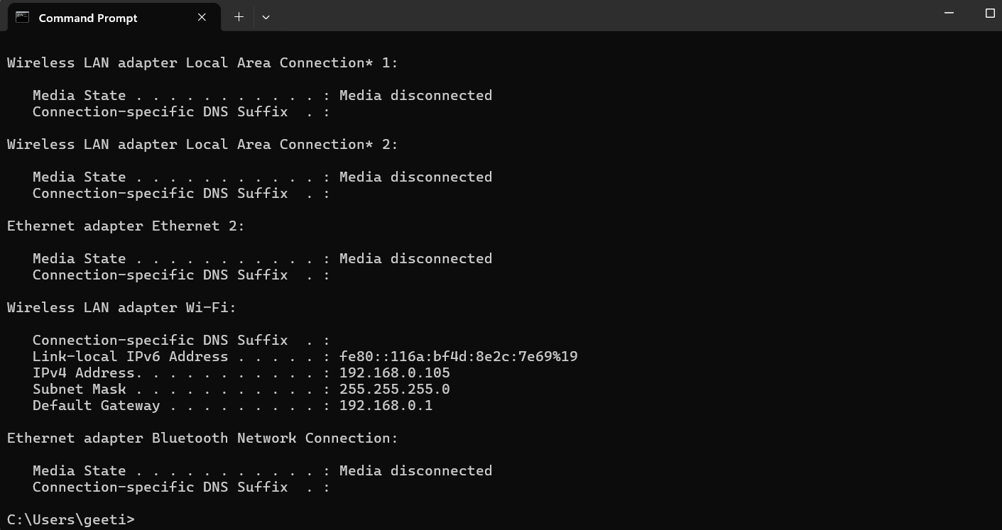

Web Application is successfully connecting database server installed on

VM2 : [g23ai2098-vm2](https://console.cloud.google.com/compute/instancesDetail/zones/us-central1-a/instances/g23ai2098-vm2?cloudshell=true&project=optical-loop-431604-f4) @ 34.122.183.176

Application code can be referred in “app.py“ file on Git Path:

“https://github.com/GeetikaVijay/VCC_Assignment-2_GCP.git”

* **Database connection established successfully streamlit application**

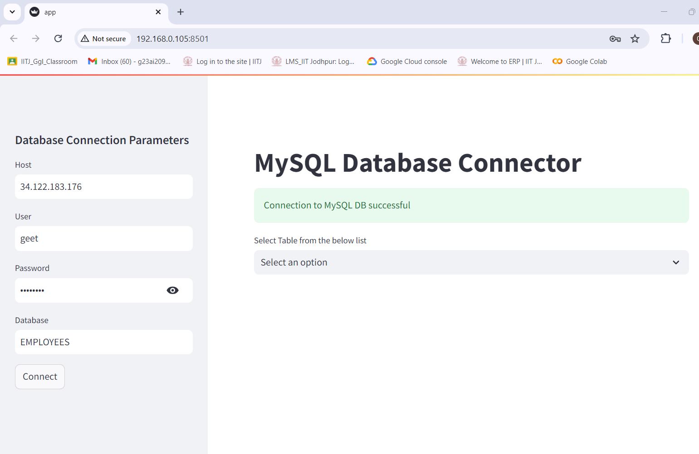

* **Data Fetched successfully on Host Machine successfully from VM2 –**

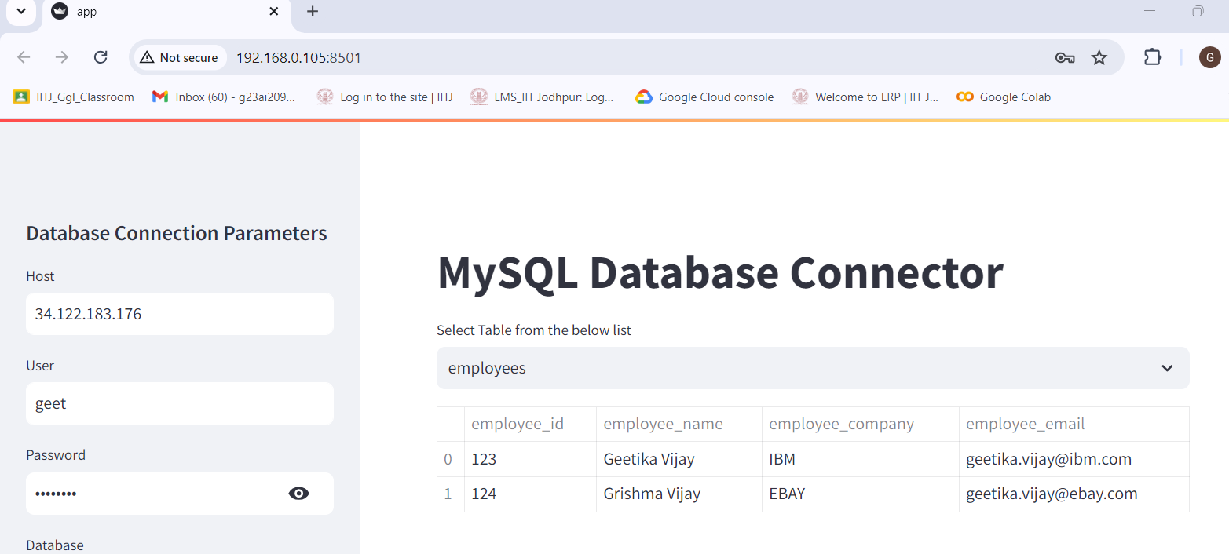

* **Data inserted successfully on VM2 from Host Machines**

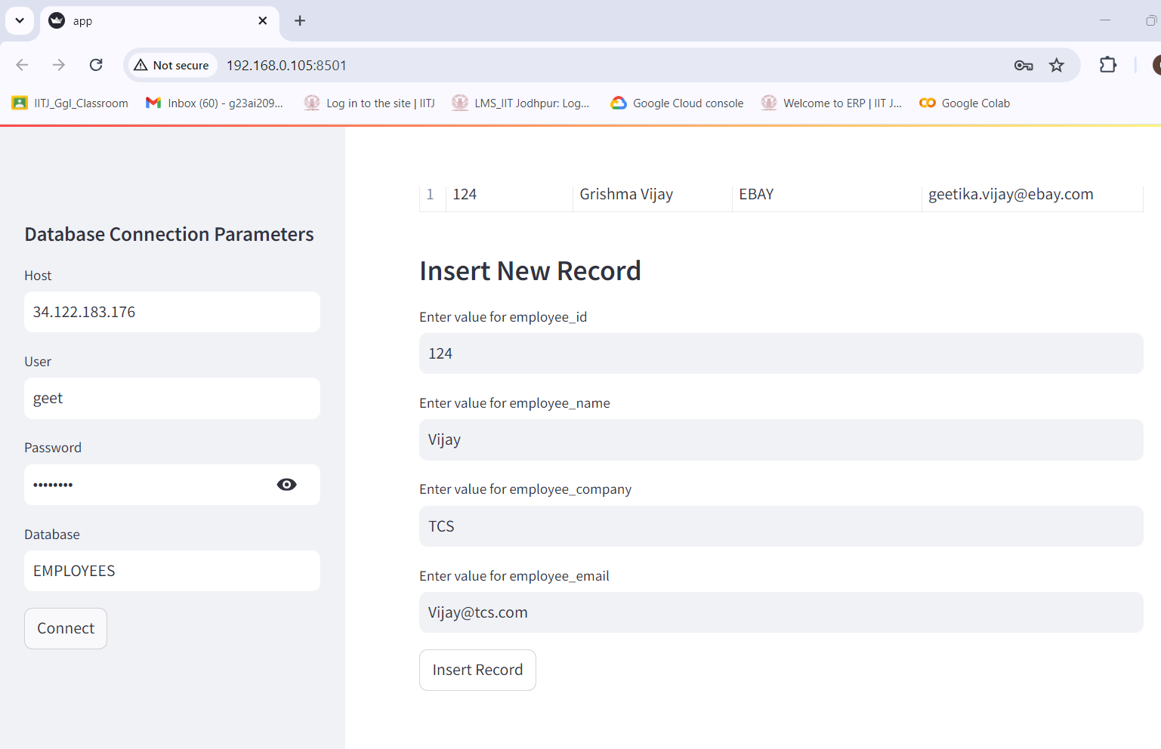

Since data is already present with 124 primary key so system raised duplicate entry.

Validation failed, which is correct. Since 2 records can not be inserted on same primary key.

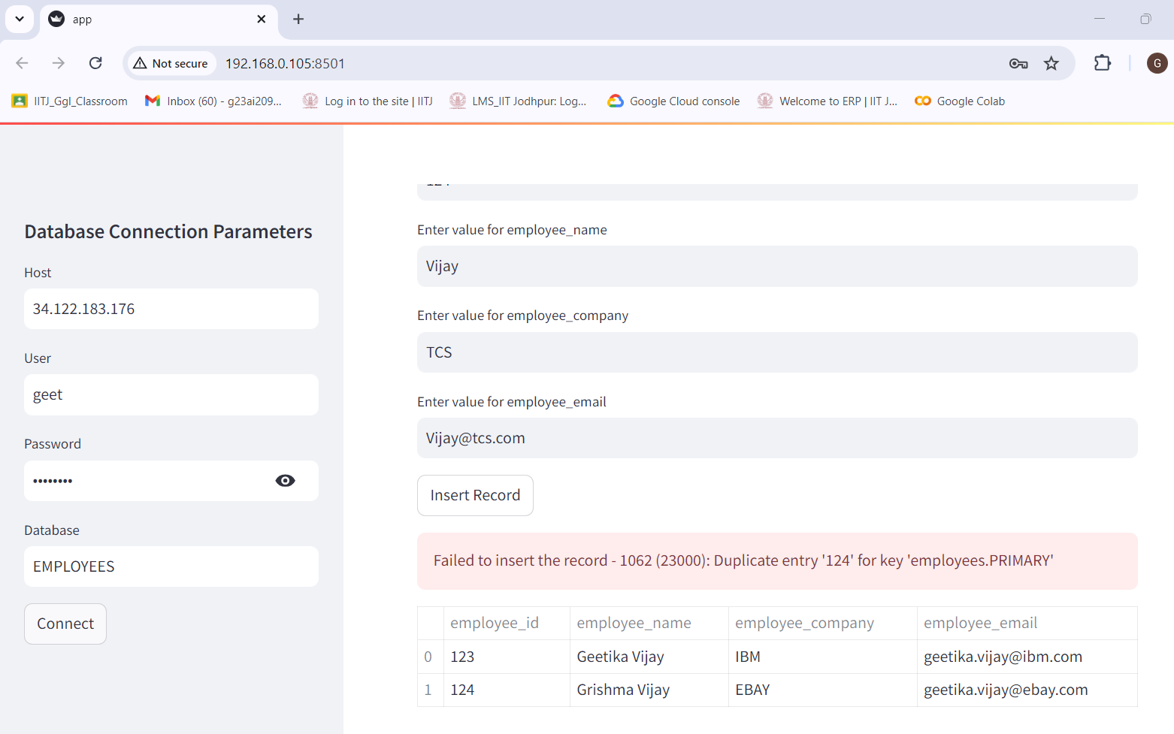

* **New record entered successfully with unique employee ID**

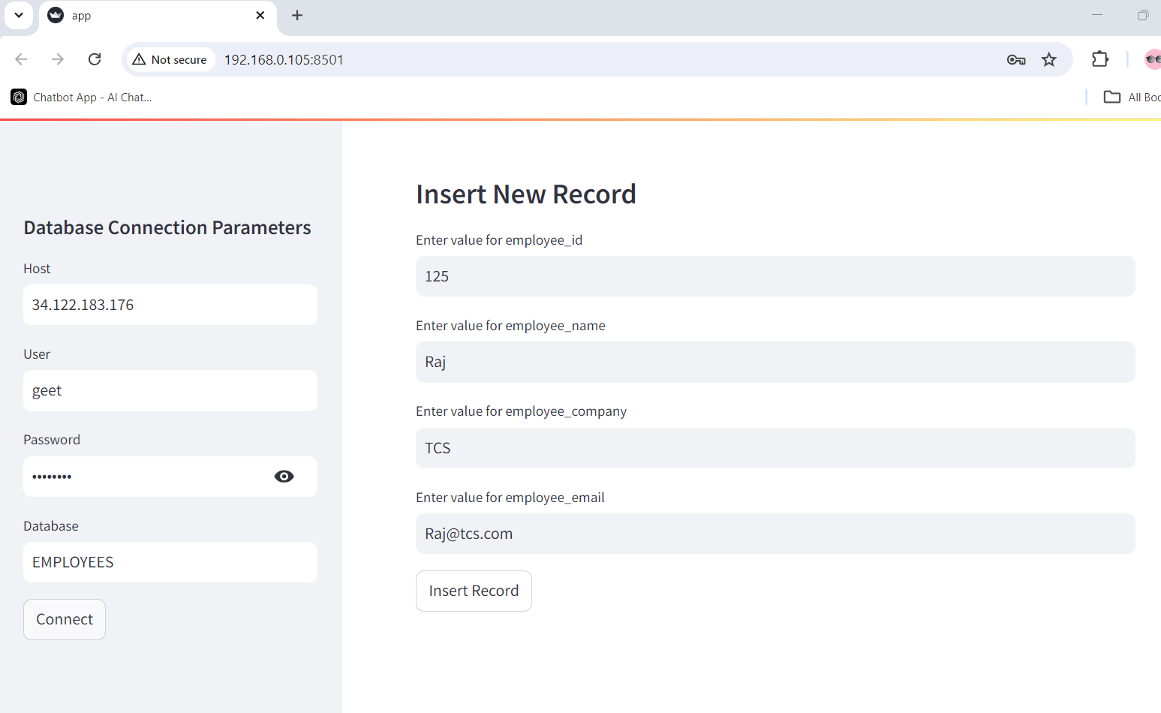

* **Record Inserted Successfully**

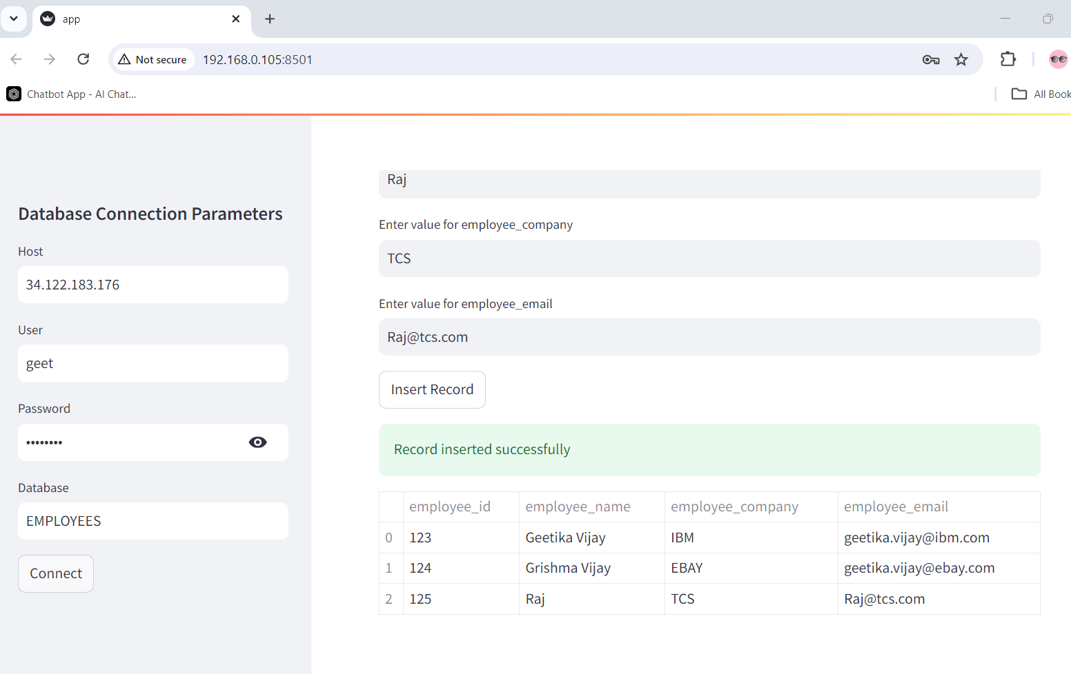

* All the 3 parts mentioned in assignments are achieved successfully.
* Records can be verified in Database as well.
* All the 3 records can be seen in VM2 machines installed successfully.

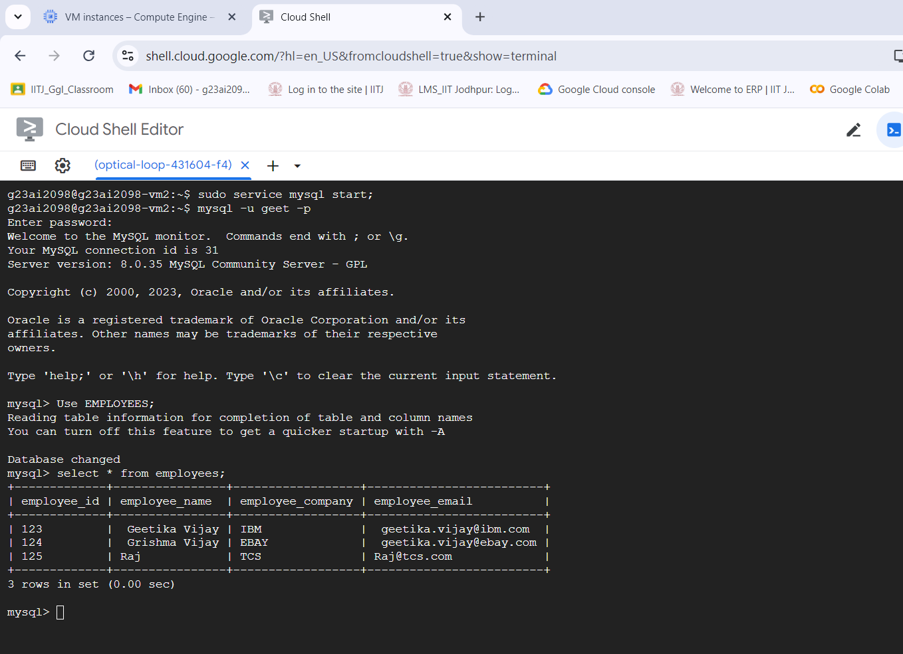

------- # FINISH # ---------

#Note: Virtual Machine public Ips changed during report creation since virtual machines stopped and started multiple time during report creation. Active Running virtual machine IP has been referred during report creation at multiple instances. Snap shots attached for running machine Ips.